**Module 4 Challenge Summary**

**Background**

The grades of the ninth graders at Thomas High School have been changed. While administrators do not know the full extent of this academic dishonesty, they want to uphold the standards of state testing and have turned to you for help.

After assessing the situation with the school superintendent and Maria, you decide the best approach is to:

* Remove the ninth-grade math and reading scores from Thomas High School.
* Keep all other data associated with the ninth-grade students and Thomas High School intact.

After removing the reading and math scores, answer the following questions:

1. **How is the district summary affected?**

Overall scores went down with the removal of the scores belonging to Thomas High School 9th grade students. Below is a before and after snapshot and you can see some examples of this with the percentage of students passing math, passing reading and overall passing each drops 1%.

District Summary without Thomas Highschool 9th graders.



District Summary with Thomas Highschool (THS) 9th graders.



1. **How is the school summary affected?** (Tables on next page)

Because the school summary has no bins based on performance the only school affected was THS. Where the affect can really be illustrated is in the is in the percentage of students passing math reading and overall. Before the students were removed the % for math reading and over all were in the mid 90%’s and after they were in the mid to high 60%’s. THS’s performance relative to other schools was also greatly affected. This will be discussed in the next question.

School Summary without THS 9th graders.

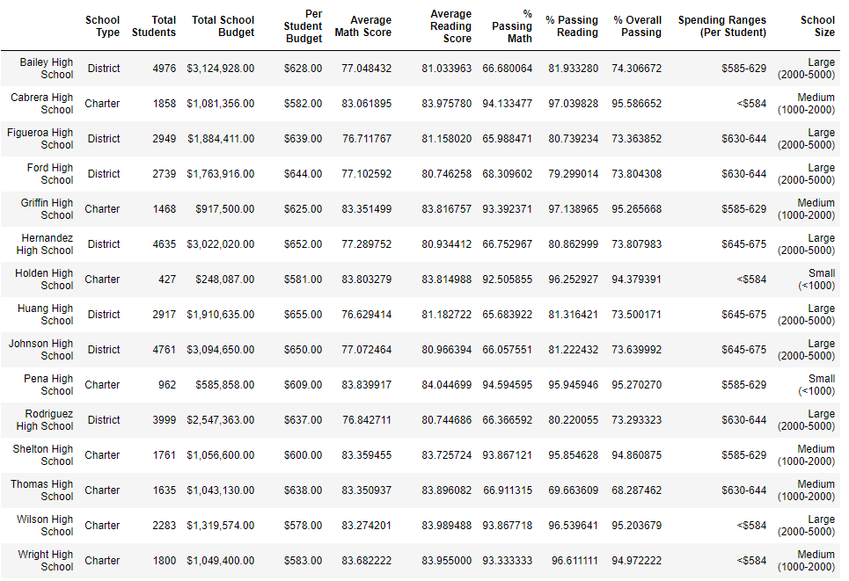

School Summary with THS 9th grade students.

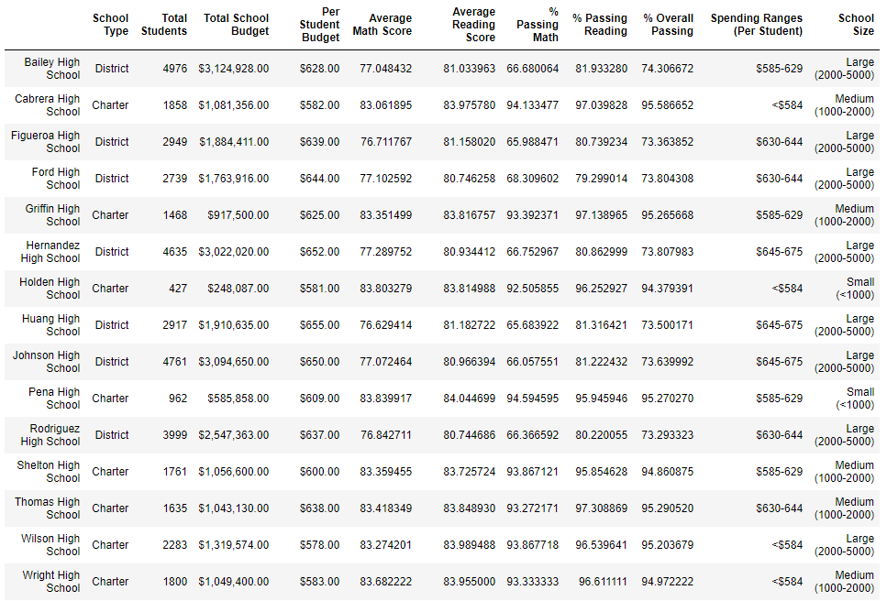

1. **How does removing the ninth graders’ math and reading scores affect Thomas High School’s performance, relative to the other schools?**

Removing the 9th graders for THS greatly impacted THS’s ranking compared to other schools as stated above. THS went from being the second ranked school in terms of overall performance(composite of % passing reading and math) to the lowest performing school based on the same metric(95.3% before and 68.3% after). Interestingly the average reading and math scores each changed less than .1%. (Possible collusion to get everyone to pass the test)

After removing THS 9th graders scores.

Top 5

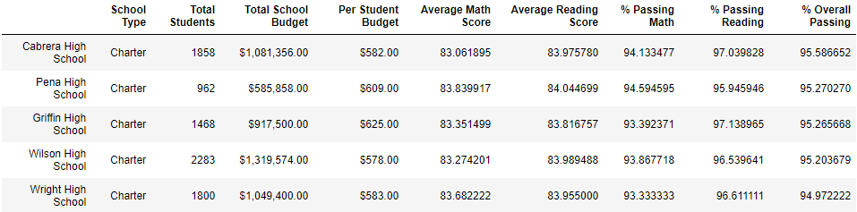

Bottom 5

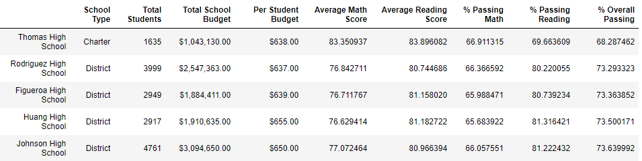

Before Removing THS 9th graders scores.

Top 5

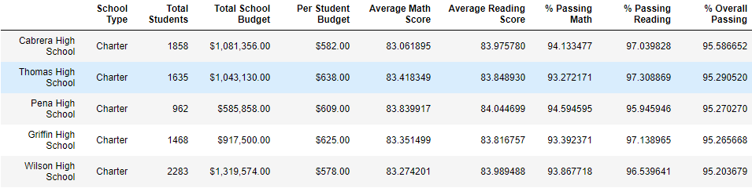

Bottom 5

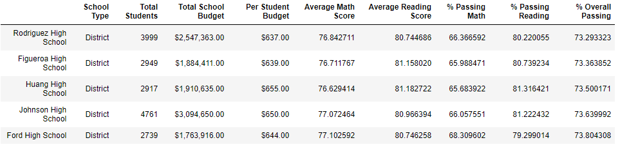

1. **How does removing the ninth-grade scores affect the Math and Reading Scores by Grade, Scores by School Spending, Scores by School Size, and Scores by School Type?**

**Math and Reading scores by grade**

The score of the THS 9th graders scores are higher than other 9th graders, 83.4% Math and 83.8% Reading for THS vs. 78.8% math and 81.8% reading for the rest of the schools. Therefore, removing them will slightly lower the averages for 9th grade as a whole.

**Scores by School Spending**

Thomas School is in the $630 to $644 bracket. The average scores for that bracket were unaffected however the percentage passing(math, reading and overall) each dropped between 6-7%.

After Removing

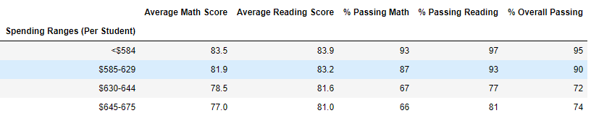

Before Removing

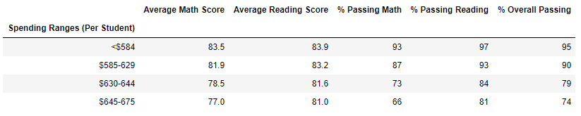

**Scores by School Size**

THS falls into the medium sized school bracket. Similarly to the spending range passing rates(reading, math and overall) for medium sized school each dropped by between 5-6% while the average scores where unaffected

After

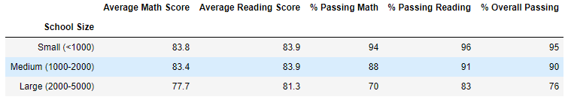

Before

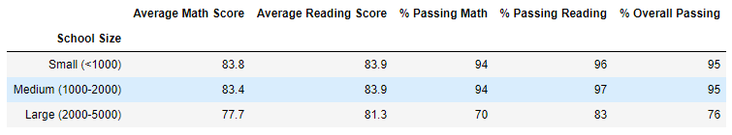

**Scores for School Type**

THS is a charter school. Very similarly to above the math and reading scores were unaffected while the passing rates each dropped by between 3-4%.

After

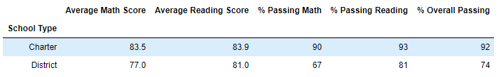

Before

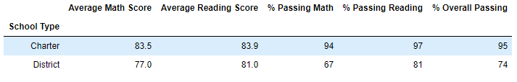

**Recalculations performed to answer the above questions.**

* + Recreate the district and school summary DataFrames.
  + Recalculate the top 5 and bottom 5 performing schools.
  + Recalculate the average math score received by students in each grade level at each school.
  + Recalculate the average reading score received by students in each grade level at each school.
  + Recalculate the school performance based on the spending per student.
  + Recalculate the school performance based on the size of the school.
  + Recalculate the school performance based on the type of school